**Rental E-Comeerce webiste**

Day:3 API Inetgeration & data migartion

Rollno: 405127

**Data Migration Process:**

* I used the API which was provide me .
* Setup sanity according the API.
* Setup schemas field naming conventions.
* Use the script to migrate data from API to sanity
* Set the sainty API token to create data

Here is script

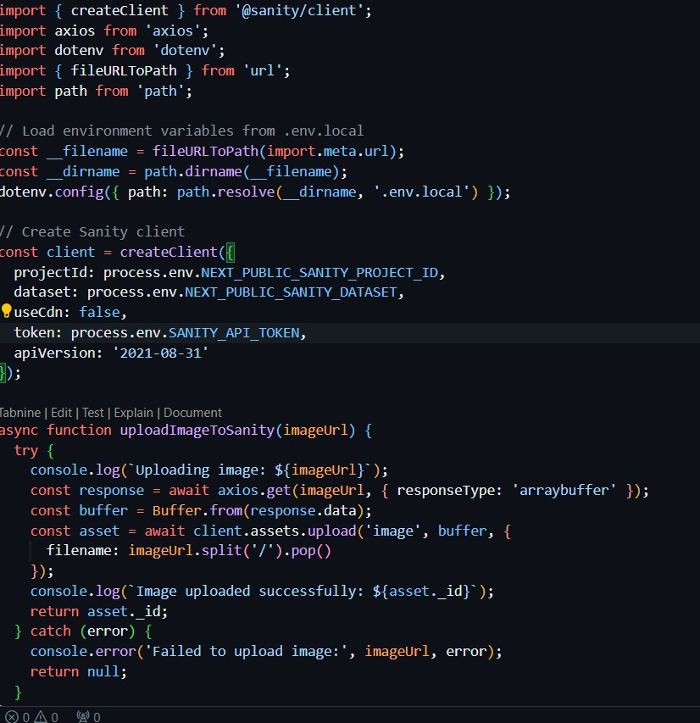

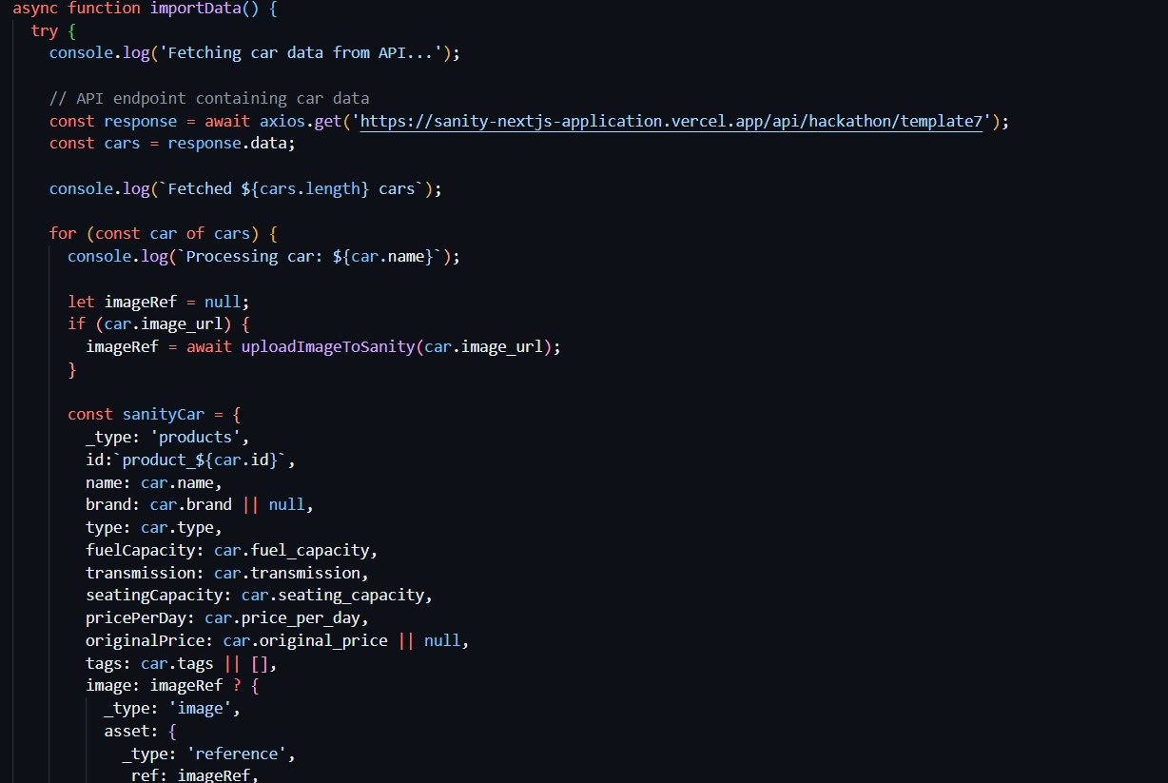

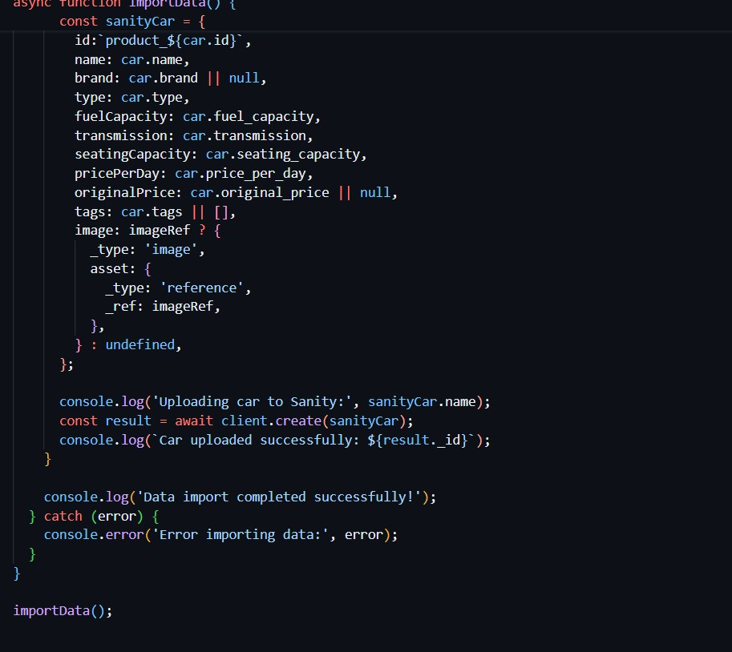

**How to setup sanity?**

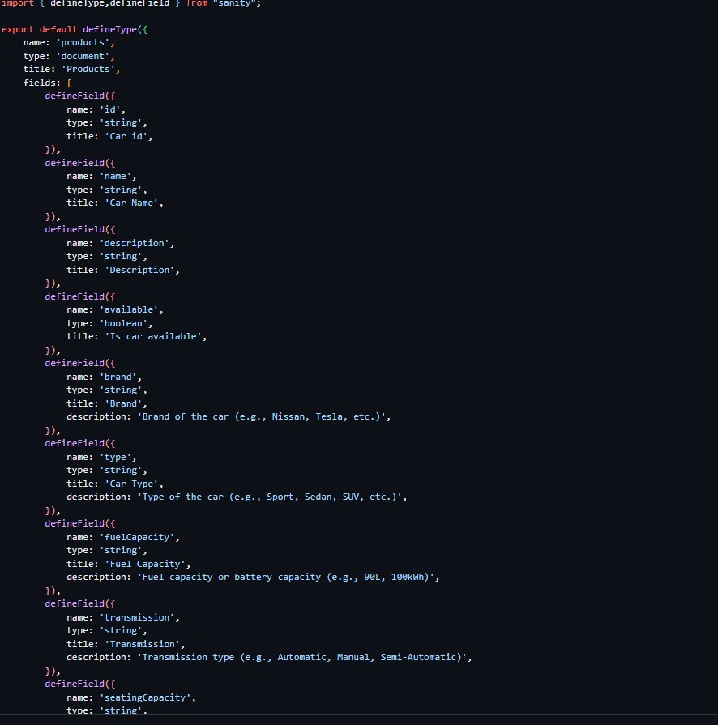

I used this process to to migrate in sanity   
with the help of grooq query data was fetched by and display in project success fully

